AI-Driven Alzheimer's Disease Biomarker Discovery and Multi-Dataset Validation
Abstract
Alzheimer's disease (AD) is a progressive neurodegenerative disorder characterized by cognitive decline and neuronal dysfunction. Identifying reliable molecular biomarkers remains critical for improving disease understanding and diagnosis. This study integrated transcriptomic analysis, machine learning, functional enrichment analysis, and protein-protein interaction network analysis to identify robust Alzheimer's disease biomarkers. Differential expression analysis was performed on the GSE5281 dataset, followed by Random Forest classification and feature importance analysis. Candidate biomarkers were validated using independent datasets (GSE48350 and GSE33000). Functional profiling was conducted using g:Profiler and protein interaction analysis was performed using the STRING database. Four genes (DNM1, MICAL2, THY1, and ARHGAP32) demonstrated consistent dysregulation across datasets and biological relevance to neuronal signaling, synaptic function, and cytoskeletal organization. The Random Forest classifier achieved an AUC of 0.912 with precision, recall, and F1 scores of 0.90. These findings suggest that the identified biomarkers may contribute to Alzheimer's disease pathology and warrant further investigation.
1. Introduction
Alzheimer's disease is the leading cause of dementia worldwide and represents a major public health challenge. The disease is characterized by progressive neuronal loss, synaptic dysfunction, and cognitive decline. Despite extensive research, reliable molecular biomarkers capable of improving diagnosis and understanding disease mechanisms remain limited.
Recent advances in transcriptomics and machine learning have enabled the identification of disease-associated molecular signatures from large-scale gene expression datasets. Integrating statistical analysis with machine learning and biological interpretation can improve the robustness of biomarker discovery.
The objective of this study was to identify and validate Alzheimer's disease biomarkers using publicly available transcriptomic datasets and computational biology approaches.

2. Materials and Methods
2.1 Datasets
Three GEO datasets were used:
- GSE5281 (Discovery Dataset)
- GSE48350 (External Validation Dataset)
- GSE33000 (Cross-Platform Validation Dataset)
2.2 Differential Expression Analysis
Gene expression profiles were analyzed to identify significantly dysregulated genes between Alzheimer's disease and control samples.
Methods:
- Welch's t-test
- Log2 Fold Change calculation
- False Discovery Rate (FDR) correction
2.3 Machine Learning Analysis
A Random Forest classifier was trained to distinguish Alzheimer's disease samples from controls.
Evaluation metrics included:
- AUC
- Precision
- Recall
- F1 Score
- Accuracy
2.4 Biomarker Validation
Candidate biomarkers were validated in independent datasets to assess reproducibility and robustness.
2.5 Functional Enrichment Analysis
Gene Ontology enrichment analysis was performed using g:Profiler.
2.6 Protein-Protein Interaction Analysis
Protein interaction networks were explored using the STRING database.
3. Results
3.1 Differential Expression Analysis
Differential expression analysis identified multiple significantly dysregulated genes associated with Alzheimer's disease.
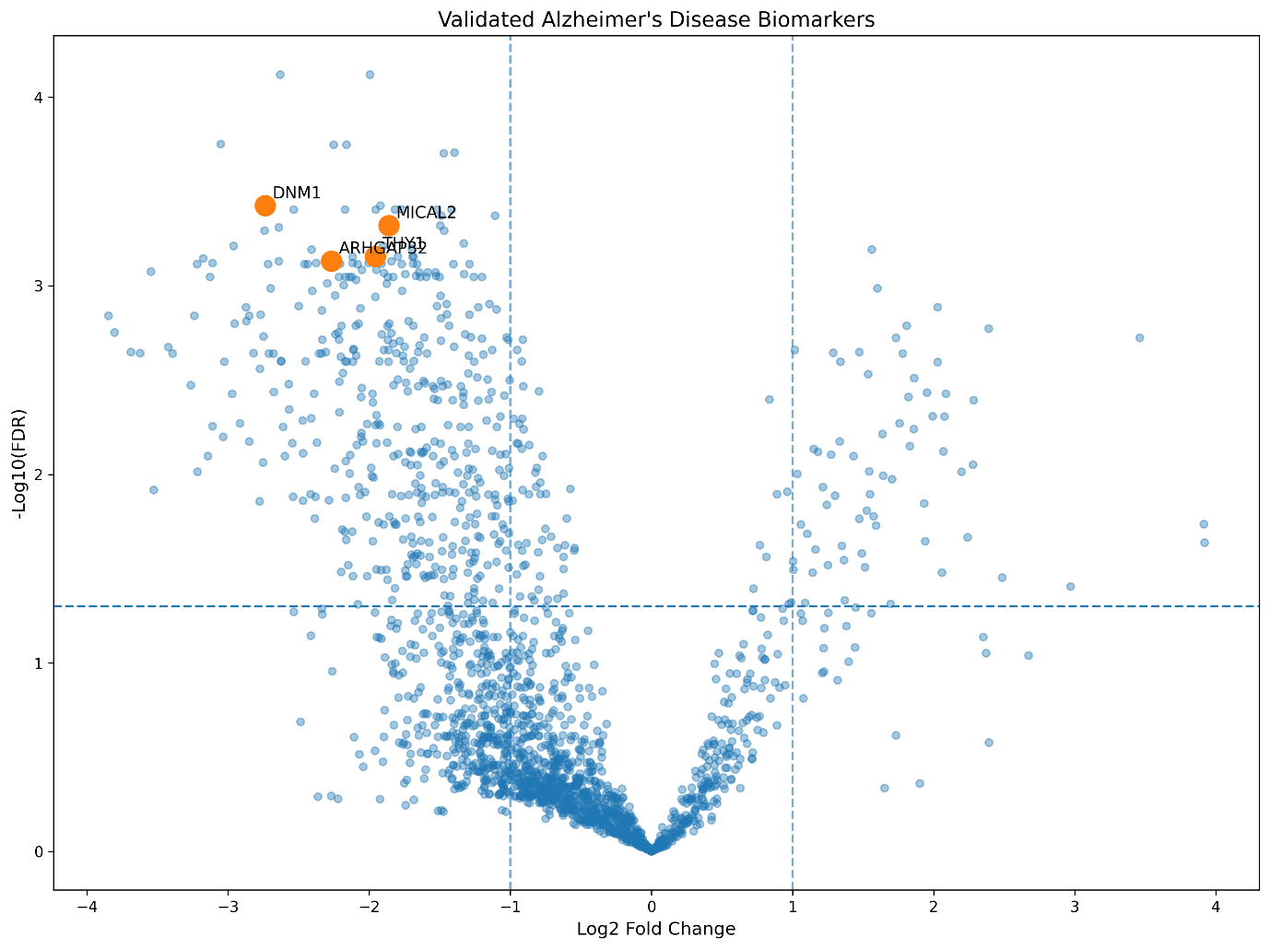
Figure 1. Volcano plot showing significantly dysregulated genes in Alzheimer's disease.
3.2 Machine Learning Performance
The Random Forest model demonstrated strong classification performance.
Metric | Value
AUC | 0.912
Precision | 0.90
Recall | 0.90
F1 Score | 0.90
Accuracy | 91.3%
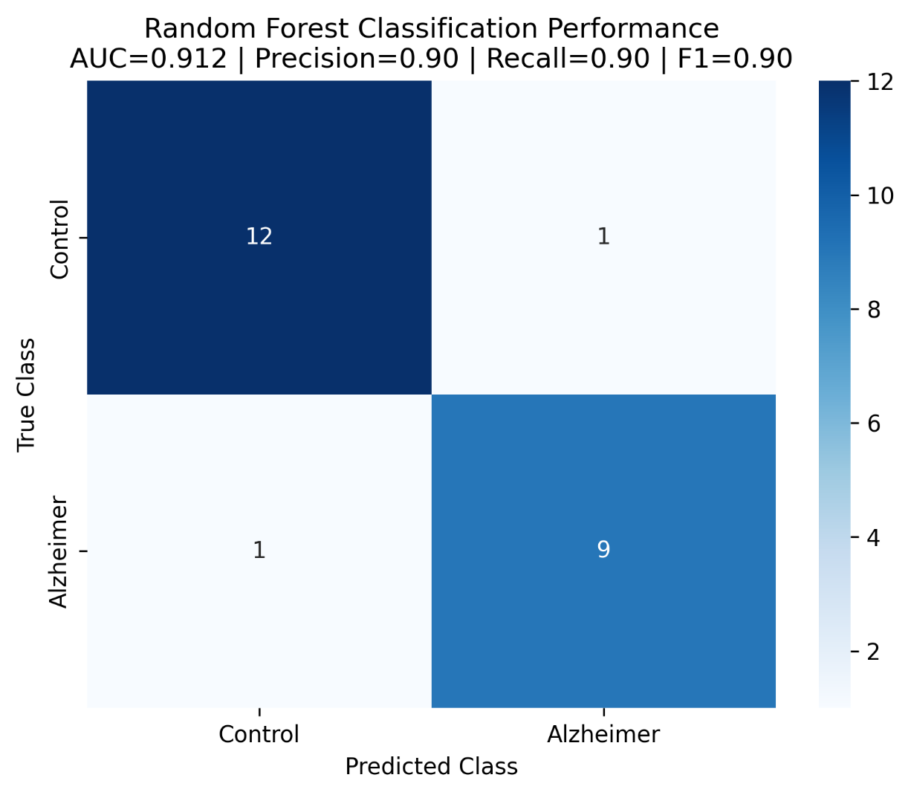
Figure 2. Random Forest confusion matrix demonstrating classification performance.
3.3 Principal Component Analysis
PCA demonstrated substantial separation between Alzheimer's disease and control samples, although a small number of samples exhibited greater variability. Control and Alzheimer's samples formed largely distinct clusters, suggesting substantial transcriptomic differences between groups.
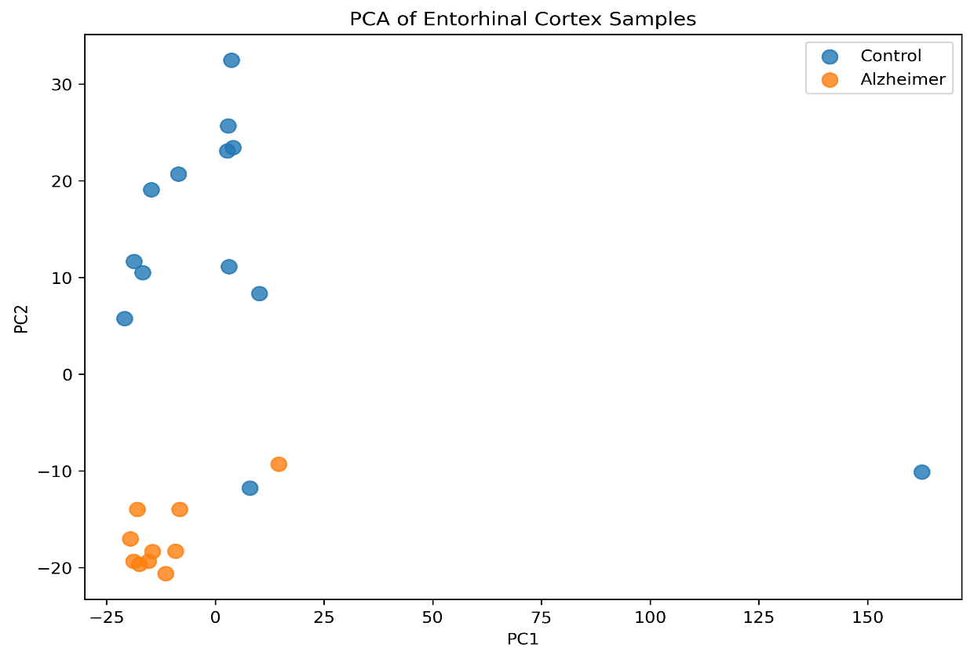 Figure 3. PCA plot showing separation between Alzheimer's and control samples.
3.4 Feature Importance Analysis
Random Forest feature importance highlighted genes strongly associated with disease classification.
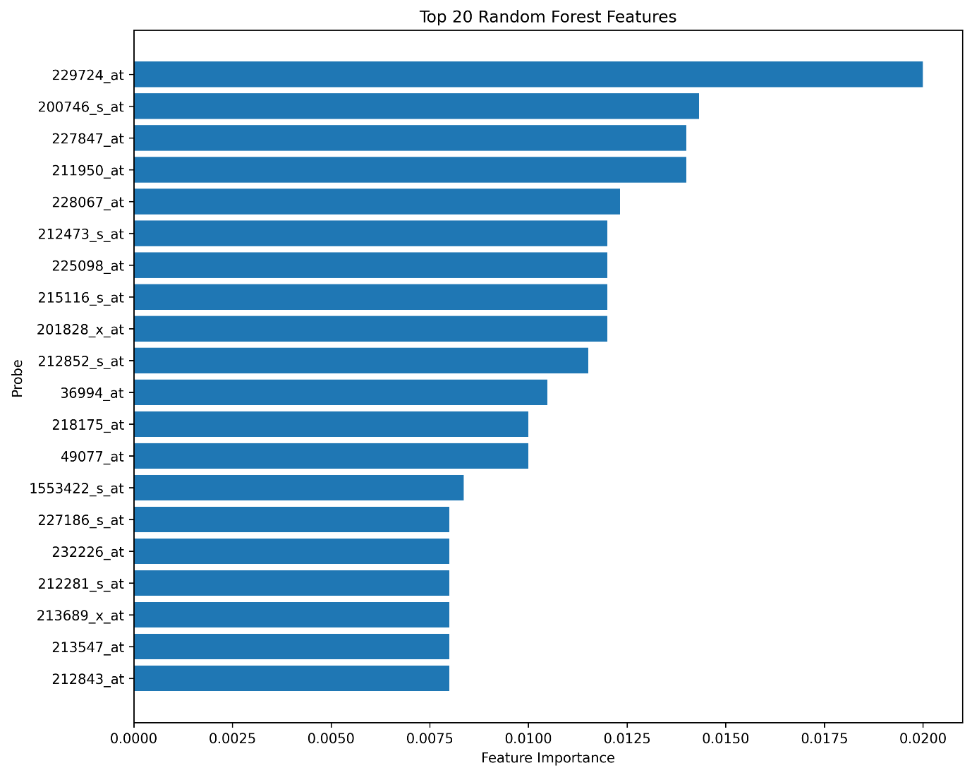
Figure 4. Top 20 Random Forest features ranked by importance.
3.5 Biomarker Validation
Four biomarkers demonstrated consistent dysregulation across datasets:
- DNM1
- MICAL2
- THY1
- ARHGAP32
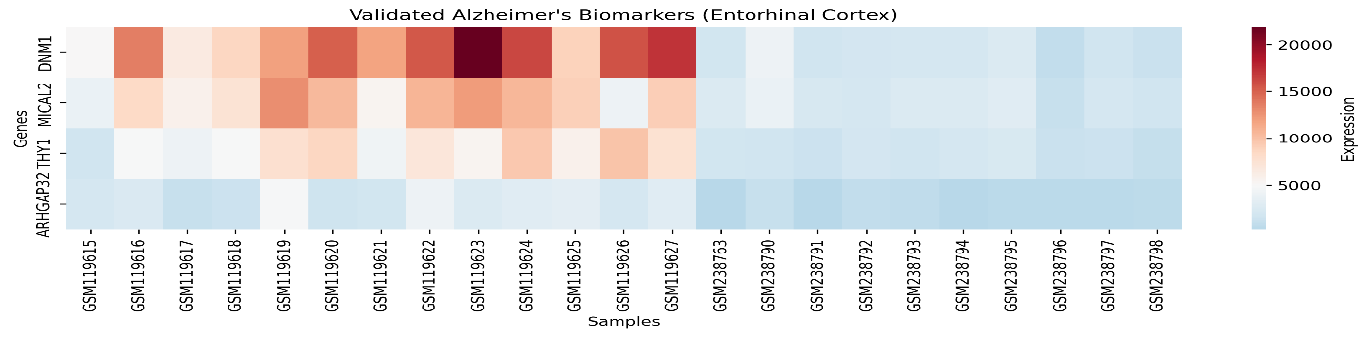
Figure 5. Heatmap of validated Alzheimer's biomarkers.
3.6 Functional Enrichment Analysis
Significant enrichment was observed in:
- Nervous system development
- Synaptic vesicle transport
- Regulation of microtubule organization
- ATP metabolic processes
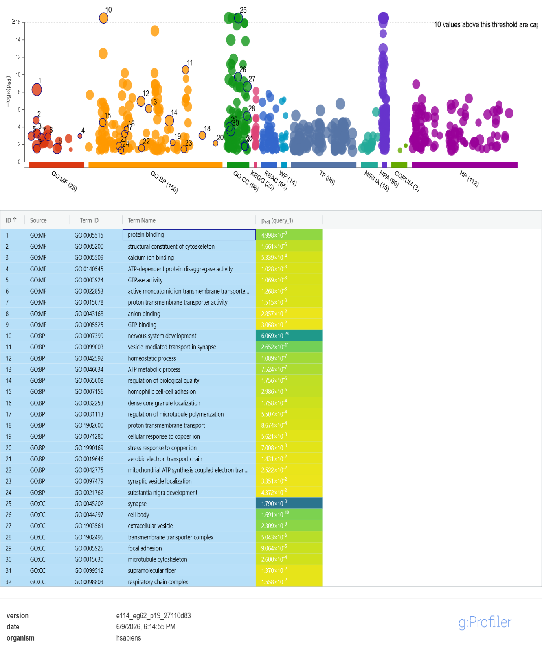
Figure 6. Gene enrichment analysis.
3.7 Protein Interaction Network
STRING analysis identified biologically meaningful interactions involving DNM1, THY1, NCAM1, and GABRB3.

Figure 7. STRING protein-protein interaction network.
3.8 Biomarker Summary Table

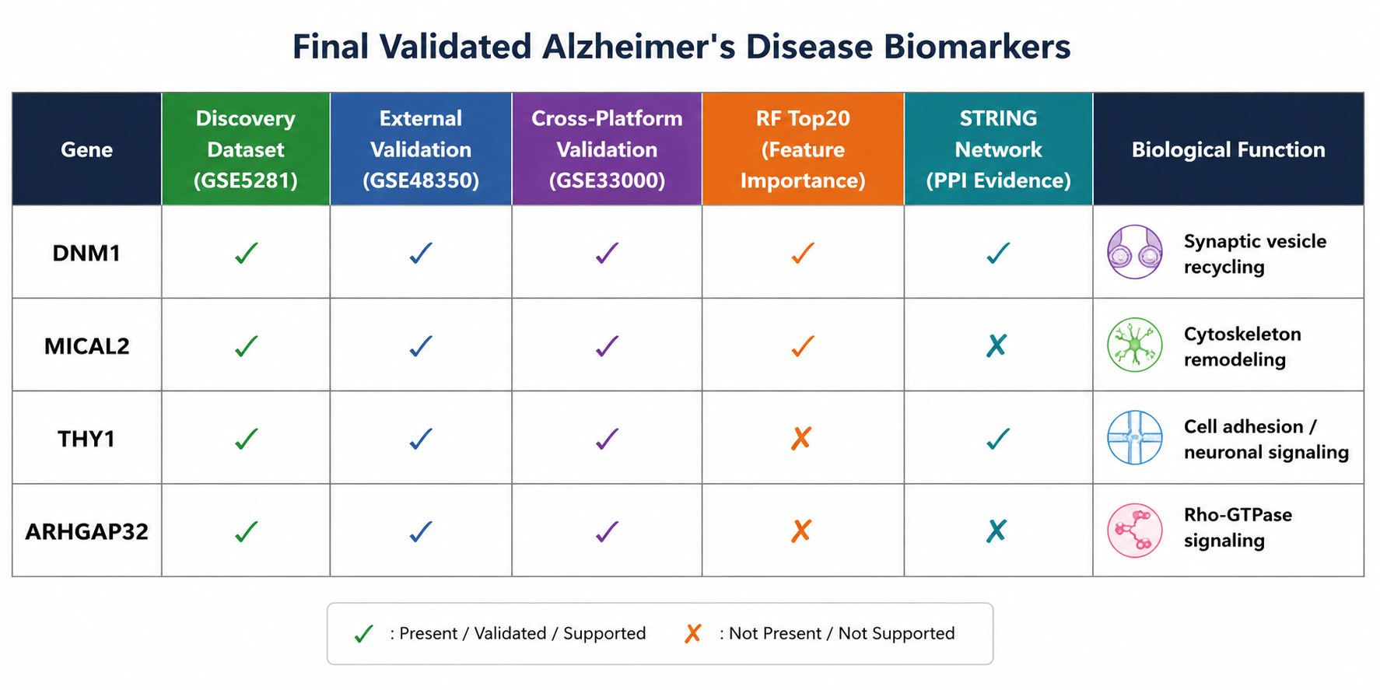
Figure 8. Final biomarker validation summary table.

4. Discussion
The identified biomarkers are strongly linked to neuronal and synaptic processes known to be disrupted in Alzheimer's disease.
DNM1 plays a role in synaptic vesicle recycling, supporting neuronal communication. MICAL2 is involved in cytoskeletal remodeling, which may contribute to neuronal structural changes. THY1 participates in cell adhesion and neuronal signaling, while ARHGAP32 regulates Rho-GTPase signaling pathways important for neuronal function.
Functional enrichment results further support mechanisms involving synaptic dysfunction, cytoskeletal regulation, and neuronal development.
The strong machine learning performance and successful validation across independent datasets strengthen confidence in the identified biomarkers.
The identified biomarkers are involved in synaptic transmission, neuronal connectivity, and cytoskeletal organization, processes known to be disrupted in Alzheimer's disease.
The agreement between differential expression analysis, machine learning prioritization, external validation, and biological network analysis strengthens confidence in the robustness of these biomarkers.

5. Conclusion
This study integrated transcriptomics, machine learning, functional enrichment analysis, and protein interaction network analysis to identify Alzheimer's disease biomarkers. Four genes (DNM1, MICAL2, THY1, and ARHGAP32) were consistently validated across multiple datasets and analytical approaches. These biomarkers represent promising candidates for future Alzheimer's disease research and may contribute to improved understanding of disease mechanisms.

6. Limitations
This study is limited by the use of publicly available microarray datasets and computational validation. Experimental validation using independent biological samples would further strengthen these findings.

References
- Raudvere U et al. g:Profiler: a web server for functional enrichment analysis. Nucleic Acids Research, 2019.

- Szklarczyk D et al. STRING v12: protein–protein association networks. Nucleic Acids Research.

- Edgar R et al. Gene Expression Omnibus. Nucleic Acids Research.

- Gene Expression Omnibus Dataset GSE5281.

- Gene Expression Omnibus Dataset GSE48350.

- Gene Expression Omnibus Dataset GSE33000.

